The Cutting Edge: Educational Innovation, Disability Law, and Civil Rights
Paul Grossman, adapted by Emily B. Moore
Abstract
Paul Grossman, Chief Regional Attorney (retired), Office of Civil Rights, United States Department of Education, San Francisco, describes foundational cases in the history of civil rights in the United States leading up to the current state of disability law, and its relationship to digital educational innovation. As Mr. Grossman guides us through civil rights history, it becomes clear that we are currently part of an historic moment in time in education technology. The rapid development of new technologies provides unprecedented opportunities to support the rights of all students to have equal access to education.
Mr. Grossman has authored and contributed to numerous scholarly articles and books on disability discrimination, most recently, The Law of Disability Discrimination for Higher Education Professionals (LEXIS-NEXIS 2014) (co-authored with Ruth Colker). http://www.lexisnexis.com/store/catalog/booktemplate/productdetail.jsp?pageName=relatedProducts&prodId=prod20900324
This paper is adapted from Mr. Grossman’s keynote presentation at the annual Accessing Higher Ground conference (http://accessinghigherground.org), November 17-21, 2014 in Westminster, Colorado (with permission). Video recording of the presentation, with real-time captioning, is available at: http://bit.ly/1DK6pGh. The audience was composed of civil rights advocates, disabled student service directors, college administrators and academic personnel, software developers, electronic information technology (EIT) experts and compliance officers. The objective of the speaker was to highlight the challenges and common ground these individuals share in making EIT accessible to students and other individuals with disabilities.
Introduction
Together, we are at the cutting edge of the progression of disability law, innovation in education, and civil rights law in general. If we stay in our professional silos, if we do not collaborate at this very moment, we are going to miss not only a golden opportunity, but also a critical moment. Clearly, technology – access to the digital world – is the issue of the moment in disability rights, and the precedents that we set in this area are spilling into and enhancing developments in other areas of civil rights.
I do not know how many of you remember James Burke and his program “Connections.” Each program would take its viewers through a series of connected, successive innovations, showing, for example, how the invention of the loom was foundational to the development of the mainframe computer. Similarly, I want to take you through a little civil rights history, through five or six stages of civil rights developments. Each stage views discrimination and how one measures equality in a little different manner. In general, each stage is more sophisticated, complex, and insightful than the preceding one. I will go with you through these stages, because it is critically important that you understand the civil rights context into which your work falls at this very moment. As we proceed, I want you to think about this question: What do the educational civil rights of Cantonese-speaking children in Chinatown, San Francisco have to do with your job? And the answer, as you will learn, is everything.
Stage 1: Connection to Wounded Warriors
Stage 1 of the five, maybe six, stages was the Emancipation Proclamation of 1863. Of course, this proclamation was about race, not about disability.
If you read the works of Abraham Lincoln, you know that he expressed hostility towards slavery from a young age. However, for some time, his “solution” to the “slavery question” was colonization -- sending African-Americans back to Africa. That is what he expected to happen after the Civil War, but a change came over him. As African-Americans entered the Union army, he realized that he could not expel from this nation the very people who had risked their lives to hold it together.
So do we, in the digital world, have any connection to the Emancipation Proclamation? It is a bit of a stretch, and we will see much closer connections in later stages, but the answer is yes, because we now have thousands of wounded warriors coming back to the United States. Some of them are so disabled that the only way they are going to get access to a post-secondary education is through assistive technology and access to the digital world.
Stage 2: Desegregation
In 1954, in Brown v. Board of Education, Supreme Court decided, decided that “separate but equal” was not constitutional. “Separate but equal” was stigmatizing. It suggested that one group of individuals was inferior to another. Is there a connection to the digital access world?
I see two connections. When I worked for the Office of Civil Rights (OCR), I would frequently visit post-secondary educational institutions. They would have a digital assistive technology lab, generally connected with the disabled student services office, but that was the one and only place that you could find assistive technology. You could not find it in the math lab or in the chemistry lab. But where were the teachers that those students needed for their particular professional choices? They were out in the math lab. They were out in the chemistry lab. So it has come to pass now that one way in which OCR has found violations of Section 504 of the Rehabilitation Act and Title II of the Americans with Disabilities Act (ADA) is on a concept of segregation, because assistive technology is only available at the disabled student services office. In some of OCR’s bigger settlements, it is now required that adaptive technology must be disbursed across the campus.
I would also note that, conceptually, the opposite of segregation is integration. In this vein, OCR has established “integration of the user” as one of the elements of providing equal educational opportunity. Can individuals with disabilities integrate into your online learning system, or are we going to leave them by the side of the road, getting passed by progress?
Stage 3: Disparate Treatment
The third stage is what we call in the law “disparate treatment” and that means that similarly-situated people should be treated the same. This concept is most often associated with a 1973 Supreme Court decision, McDonnell Douglas Corporation v. Green. As a simple example: you have a law firm, it has a rule, one hour for lunch. Nonetheless, Caucasian clerical employees are regularly permitted to take an hour and 15 minutes for lunch. An African-American clerical employee is dismissed, because she took an hour and 15 minutes for lunch. That is clearly discriminatory – it is disparate treatment. Similarly-situated people should be treated by their employers in the same manner. Here equal treatment means identical treatment.
Stage 3 and Measures of Equality
Now, this is the last stage that many Americans accept as the sum and substance of our civil rights. But think for a minute. If you treat people with disabilities in a manner identical to that of people without disabilities – for instance, no such thing as reasonable accommodation, no such thing as academic adjustments, no such thing as use of assistive technology – are you always providing an equal educational opportunity? I think clearly the answer is no.
So, although people sometimes gets stuck at Stage 3, this stage is two or three stages short of where the law requires us to go, and we need to support our colleagues to get to Stage 5 or Stage 6. And, of course, I will explain those stages in a moment. But I want you to pause for a second and think about: what are measures of equality?
We had this very simple measure of equality: if white people can do this, then African-American people, who are similarly-situated, should be entitled to do it as well. But in the digital world, what are the measures of equality? Together, we are going to have to think about what we want represented as the way to view or measure equality in the digital world.
Stage 4: “Unnecessary Headwinds” - Disparate Impact
In 1970 we have a landmark decision by the Supreme Court, Griggs v. Duke Power. This decision established a new approach to establishing discrimination called “disparate impact.” This is one of the hardest legal concepts that I try to explain, and yet it is so very, very important to what we do.
In 1964, the Kennedy/Johnson Civil Rights Act passed. Title VII of this Act prohibits race discrimination in employment. Prior to 1965, Duke Power Company, in North Carolina, has lines of seniority organized the way most industrial lines of seniority were organized in the South, and sometimes, elsewhere in the country. You have a white line of seniority, and you have an African-American line of seniority, and the top-paying job in the African-American line of seniority is just below the bottom-paying job in the white line of seniority. So now, due to the Civil Rights Act of 1964, this approach to classifying industrial employees is illegal. What is Duke Power going to do?
Duke Power Company says, we got it. We are going to go to objective selection criteria. From now on, to get the higher-paying jobs – no longer denominated by race – you must have a high school diploma and get a passing score on the Wonderlic and Bennett quick intelligence tests. The job in question that the Supreme Court of the United States looked at was Steam Generator Operator. By the way, if you mis-operate a steam generator, you will kill many people in the plant when it blows up, and you will cut off power to hundreds of thousands of people. This job entails a lot of responsibility.
Here is the important thing to understand in this case. When the US Justice Department argued this case in the Supreme Court, it might have argued that these criteria were adopted by Duke Power Company to keep African-Americans down. But that is not what they said were the facts. They, instead, hypothesized that if you were a white person and did not meet the criteria, Duke Power would not hire you as a Steam Generator Operator. And if you were an African-American person and you met those criteria, Duke Power would hire you.
Wait a minute, aren’t similarly-situated people being treated the same? Sounds like it to me. Either you meet the qualifications or you do not. If you meet the qualifications, you are in. If you do not, you are out. So what is the problem? Let me be clear. No evidence was introduced of intent to discriminate, to have a purpose of discriminating.
What is wrong is that, if you are a white male in North Carolina in 1965, your chances of having a high school diploma, albeit small, are three times greater than that of an African-American (12% v. 34%). Similarly, your chance of getting a passing score on the quick intelligence tests, never normed on an African-American population (which had been required to attend segregated schools), is about 10 times greater (58% v. 6%).
The outcome, even though the rule is neutral on its face, is discriminatory. So here is what the Supreme Court (and the Equal Employment Opportunity Commission [EEOC]) said, if these criteria are valid predictors of who will do the job of Steam Generator Operator well, more power to you. Use your criteria. Let the chips fall where they may. But if they are not a good predictor of who will do the job well, what you have here is an “unnecessary headwind.” Got it? You have a rule, a standard, a criterion that greatly reduces the opportunity for employment by African-Americans, but has no actual value. It looks objective, but it is not. It purports to be about merit, but it is not.
Now, this concept, intent-free disparate impact, is at the heart of the regulations that OCR, the Department of Justice, and advocacy groups such as the National Federation for the Blind use when they look at your universities. They are not arguing that you hate people with disabilities. They are not arguing that you were trying to disadvantage people with disabilities. They are pointing out that your “method of administration,” how you do business, has a discriminatory impact, and unless it is an undue burden to undo that discriminatory impact, unless it's a fundamental alteration to undo that discriminatory impact, you are guilty of disparate impact discrimination.
Stage 4 and Disability Law
Is this concept of disparate impact accepted in disability law?
Along comes the Supreme Court case of Alexander v. Choate in 1985. The question in Alexander v. Choate is, did it violate Section 504 of the Rehabilitation Act to cut Kentucky Medicaid benefits from 20 to a 14-day maximum?
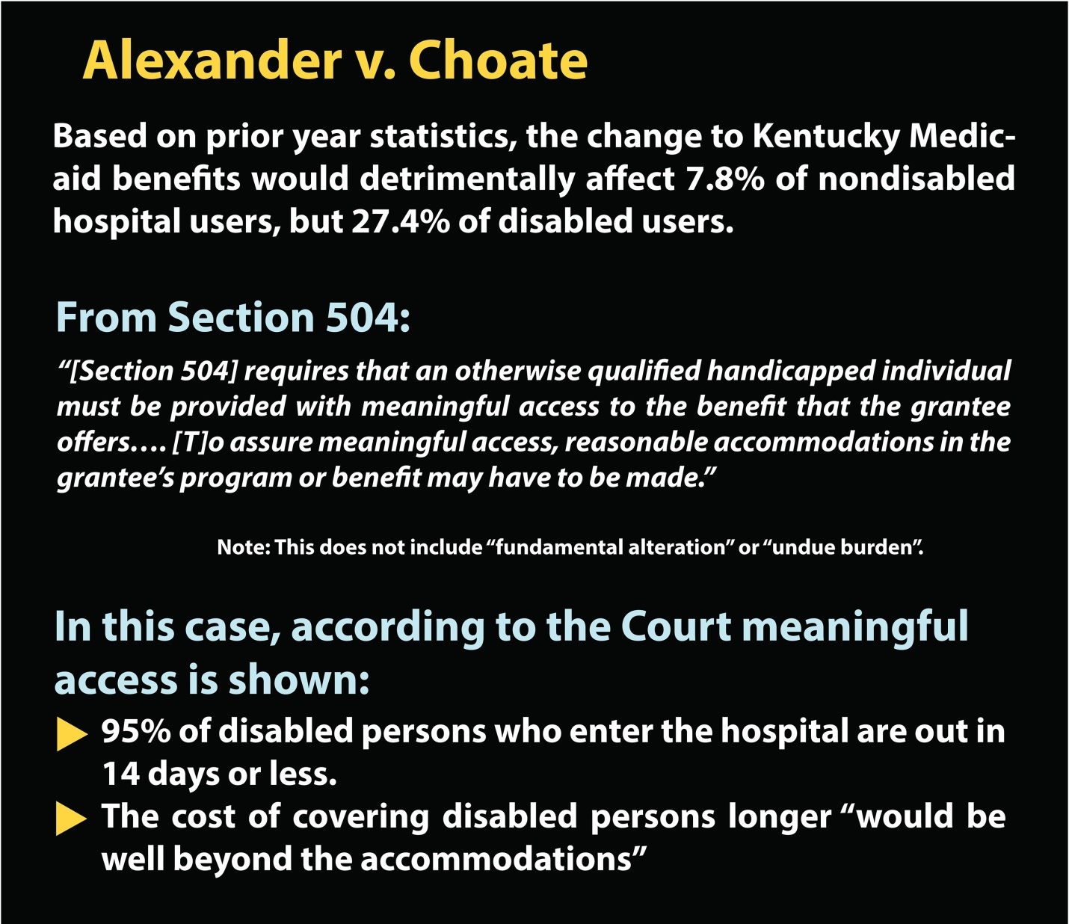
Figure 1. Alexander v. Choate: Relationship to Section 504, and determination of “meaningful access”.
You can see from the statistics in Figure 1 that people with disabilities were much more harshly affected by this rule than people without disabilities. The Supreme Court said yes, you could use disparate impact analysis to look at this issue.
But, if the cut still allows people with disabilities to have “meaningful access” – their words, then it still might not be discriminatory. Since 95% of disabled persons who enter the hospital are out in 14 days or less, individuals with disabilities still have meaningful access. Note, here, “meaningful access” seems to be a limitation on the duty to accommodate – it is a shield.
Later, you will see that “meaningful access” is a sword, because colleges and universities must provide meaningful access to every one of their programs and activities, including those that are provided through digital technology and media.
Out of this case comes a standard which your colleges and universities must meet, and also comes a concept, which is very important to equal educational opportunity, that of meaningful access.
I just want to show you something here in the Section 504 Disparate Impact regulations in Figure 2.
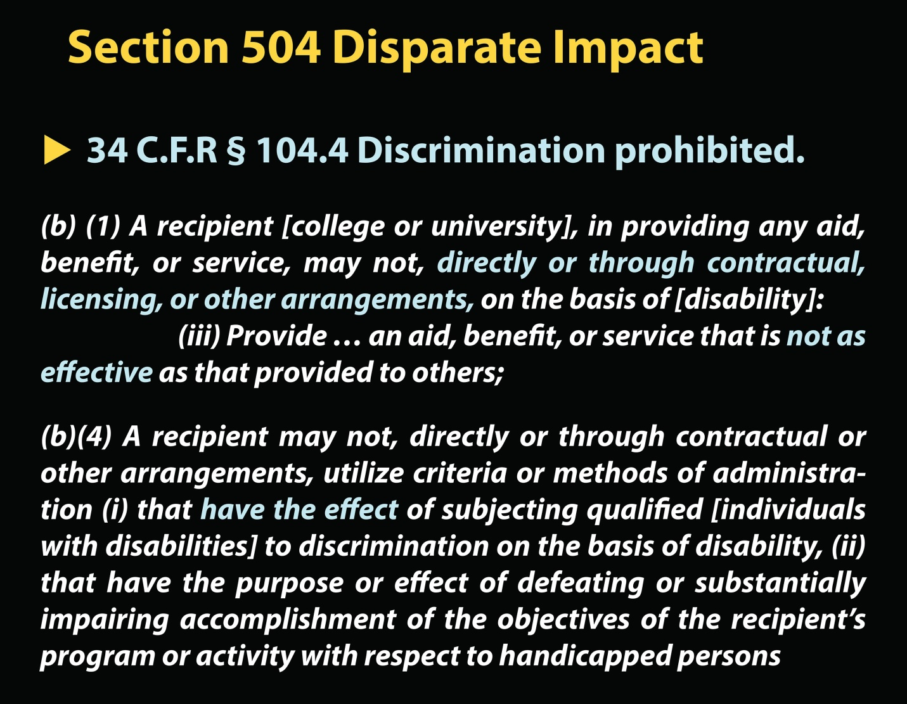
Figure 2. Section 504 – Disparate Impact
When you buy software, you go through a “contractual, licensing or other arrangement”.
You may not discriminate. You may not “provide an aid, benefit or service that is not as effective as that provided to others”. Nor may you adopt criteria that discriminate. Remember Griggs v. Duke Power? Criteria or methods of administration – which is how you acquire your software, how you operate your online programs – that have the effect of subjecting individuals with disabilities to discrimination are prohibited. This concept comes right out of this Supreme Court law.
I want you to know that the ADA Title II says almost the same thing. And there is one more tick in Title II, and that is the concept of maintenance of access. It says you must maintain your accessible features. In other words, when you set up a system of assistive or accessible technology, you cannot just let it slide. You have to keep it in conformance with disability law.
You have to keep it operating in an accessible manner.
Stage 5: Identical Treatment is not always Equal Treatment
Remember my earlier question; what do the educational civil rights of Cantonese-speaking children in Chinatown, San Francisco have to do with your job? Well, here we are. The case that went to the Supreme Court was Kinmon Lau, a child who resides in Chinatown San Francisco, versus Nichols, who was then the Superintendent of schools in San Francisco. Lau v. Nichols was brought by the Justice Department and the U.S. Department of Education Office of Civil Rights in 1974. What is going on in this case? There is Lau in Chinatown. Young Mr. Lau only speaks Cantonese, and his teachers only speak English. Lau, through the Department of Education Office of Civil Rights, argues that not addressing his unique language characteristics is discriminatory. The San Francisco Unified School District says, you must be nuts. We give the children in San Francisco, in Chinatown, the exact same qualified teachers, same years of experience, same dollars per pupil, same square footage classroom space, same books and on and on. Name an objective comparative factor and we do just as well in Chinatown as we do in the wealthiest parts of San Francisco.
We (OCR) say through a document called the May 25th Memorandum, that OCR has the authority to interpret what is equal educational opportunity under Title VI of the Civil Rights Act of 1964, and we have decided that public school districts must take into account the fact that not everyone comes to the starting line with the same basic skills and same basic characteristics. To not take these differences into account is discriminatory. Is it starting to get clear where we are heading? The Supreme Court says, we are not going so far as to say that it is self-evidently discriminatory to fail to treat these national origin minority children differently. What we are going to say is that, the Office of Civil Rights has the authority to interpret what “equal” means and requires within its expertise. If it wants to say, identical treatment is not always equal treatment that is within its authority.
The authority of the Department of Education to look at people who are uniquely situated and decide that school districts must do something affirmative or positive for them is affirmed in Lau v. Nichols. I was there in Washington and I helped prepare the head of DOJ’s Civil Rights Division, J. Stanley Pottinger, for his argument before the Supreme Court in Lau. Here is the inside baseball that I want you to know – the minute that the Supreme Court decided that OCR had the authority to decide identical treatment is not always equal treatment was the moment OCR decided we have the authority to issue regulations on behalf of individuals with disabilities and conclude that reasonable accommodation, academic adjustments, and related aids and services (assistive technology) may be necessary in order to provide equal educational opportunity. Without Lau, your mission would not exist.
Stage 5 and Reasonable Accommodation at Colleges and Universities
The Supreme Court next confronts this question in Southeastern Community College v. Davis in 1974. Ms. Davis is a Licensed Practical Nurse (LPN) who wants to become a Registered Nurse (RN). Southeastern Community College interviews her and realizes she is an individual with a serious hearing impairment and, even with a hearing aid, must rely on lip-reading for effective communication. Ms. Davis, for example, would have a hard time communicating with a surgeon wearing a face mask.
Very wisely, the College did not tell her to go away. Instead, they called other colleges and asked if they had ever had a nursing student who is deaf? How did you work with that student? All of the schools said, we have not done it. We do not see how you could safely do it. Then Southeastern Community College called the state licensing entity and asked, would it admit to the practice of nursing a deaf nurse? And the licensing board said no, not safe. So Southeastern Community College told Ms. Davis, sorry, we have looked into this. We have thought about this carefully. We cannot find a way to license you as a safe individual. We will not admit you to our program. So Davis sues under Section 504 of the Rehabilitation Act of 1973.
The case goes all the way up to the Supreme Court. The Supreme Court hears two very different positions argued. Davis argues, whatever I cannot do because of my disability, you cannot hold against me. You cannot make it a selection criterion. So if, for example, I cannot hear in the stethoscope, you cannot hold that against me. Section 504 says you cannot discriminate on the basis of disability, and that is what you would be doing. The College argues the polar opposite position, which is, the only thing Section 504 tells us is we cannot arbitrarily exclude people because of disabilities. We cannot have a rule that says “no people with disabilities need apply”. But beyond that, we have no duty. So if this were old-fashioned, purposeful, Stage Three disparate treatment, discrimination, yes, Section 504 would cover it. Forget about Stages Four or Five.
The Supreme Court Justices, in their wisdom, found a middle ground. They said yes, you do not have to admit to the practice of nursing someone who cannot, even with the benefit of “modifications” (reasonable accommodations), meet your essential qualifications. In other words, providing reasonable accommodation is an element of determining qualifications. Today, if a student cannot meet a college’s essential academic and technical standards, even with accommodations, like assistive technology, alternate media or captioning, then, okay, he or she is not a qualified individual. Nor are colleges and universities required to provide modifications that are “unreasonable,” that is accommodations that entail a “fundamental alteration” of their programs or a lowering of essential academic standards. However, if with auxiliary aids and services that are reasonable, a student can meet the college’s standards, then the student is a qualified individual with a disability and entitled to the full protections of Section 504 and ADA.

Stage 5 and Measures of Equality
The May 25th Memorandum was the OCR guidance that the Supreme Court approved in Lau. We now have a digital-era analogy to the May 25th Memorandum, and it comes up through the Dear Colleague Kindle Letter in 2010. To make a long story short, Amazon wanted to do to the bookstore what iTunes did to the record store. They wanted to eliminate the bookstore by having students buy all of their books online through Amazon, and they would be read on the Kindle reader. To promote this idea, they set up pilot test sites with Kindle-only course sections. A good number of these were STEM classes, by the way.
What was wrong with this? At the time, the Kindle Reader was not accessible to people who were blind or people with severe low vision. Well, wait a minute. The Kindle Reader will read the text aloud. Yes, if you can find a way to tell it to do so. But unfortunately, the only way to tell it to read the text aloud was to use the pull-down menu, and the pull-down menu was not accessible to individuals who are blind or have severe low vision.
So, the National Federation for the Blind decides to file four complaints with OCR, and one complaint with the Department of Justice. The Department of Justice makes an example of Arizona State University, and takes it into court. OCR opens up cases against Case Western Reserve, Pace University, Princeton, and Reed College. In response to these complaints, OCR and the Department of Justice say, the exclusive use of the Kindle is discriminatory, because this way of delivering information has the impact of excluding students who are blind or low vision.
Here is the insight that I want you to take away from the Kindle cases: the most important thing to look at is what measures of “equal treatment” OCR and the Department of Justice applied in finding noncompliance – because these are not measures of equality applied historically in race, national origin, or gender cases. These measures are new, first introduced and applied in the digital world. The measures are: can the student “acquire the same information, engage in the same interactions, enjoy the same services as sighted students, with substantially equivalent ease of use”. This is not bare-bones access, is it? This is not having someone sit next to you in the library and read to you, which, before the Kindle cases came out, was pretty much what would have been acceptable in the law.
Here they have given you four new measures of compliance, and the reason for these measures is to see that individuals with disabilities get to work independently and self-sufficiently. Independence and self-sufficiency become, from the Kindle Letter on, measures of equality.
So, I am going to share from the guidance that is found in the OCR Dear Colleague Kindle Letter, the guidance that came out following the settlements in the Kindle cases. The Dear Colleague letter states:
Requiring use of an emerging technology in a classroom environment when the technology is inaccessible to an entire population of individuals, in this instance individuals with visual disabilities, is discrimination prohibited by Section 504 and the ADA unless those individuals are provided accommodations or modifications that permit them to receive all – an important modifier – the educational benefits provided by technology in an equally effective and equally integrated manner.
What is this telling you about ad hoc, after-the-fact “work-arounds”? I think it is telling you that on the horizon ad hoc solutions will not be an acceptable way to establish, achieve, or demonstrate compliance.
Stage 6: Is the Tail Wagging the Dog?
Finally, I get to the question of whether there is emerging a sixth stage – a post-Kindle stage. In this stage, “Is the tail wagging the dog?” In other words, are the developments and standards that we have recently adopted in the digital world now going to be applied back into the brick and mortar world? I want to highlight one example, and that is in access to the voting booth. Other examples exist, particularly with regard to emergency planning.
In a 2011 Federal Court case, Center for Independence v. Bloomberg, the court accepted as true that in New York City, 80% of all polling places have some form of access barrier. What the Board of Election Commissioners in New York City told the court in response to this was, whenever somebody gets on the phone and tells us, this adapted voting machine is not working, we just rush on down through the streets of New York and fix it. The court said, that is no good. Nor can the City get around this responsibility by pointing out that there is ballot by mail or that a person could sit next to the individual with a disability and help him or her with filling out a ballot. The Board of Elections' ad hoc policy of addressing barriers to access as they occur is inadequate, especially as the record shows that the Board of Elections Commissioners does not respond to many accessibility issues, even after they are brought to its attention. So, the emphasis on independence and self-sufficiency, the rejection of ad hocism, adopted in court precedents concerning the digital world, are measures of equality that are now starting to find application in other areas of disability rights and civil rights.
Conclusion
The measures or characteristics of equality have been expanded and changed over time to include: Independence of the user, integration of the user, ease of use of technology, timeliness of delivery of information, completeness of the accessible information. Equal access to information is achieved by making information available in formats that are compatible with common adaptive technology, like Jaws and ZoomText. Making access an explicit element in acquisition and implementation of technology programs and online services is going to be required.
We are hugely dependent on the gains made by people of color, by national origin minority people, and the gender rights movement. Now the ball is in our court to make the advances. And our advances, if we do them right, will actually spill over or spill back to help in the rights of everyone. So, we must – lawyers, software engineers, DSS officers, faculty, deans – we must come out of our silos and join together, do our best thinking, and aggressively address the fact that there is a revolutionary change going on in education, one that pertains to digital information and technology, and if we do not include access for individuals with disabilities as a critical element in planning for and executing this change, we are going to leave a huge population of individuals by the side of the road in violation of the law and their human rights and contrary the best interests of this nation.

